Peptide and Protein Quantification

Biological samples do not only show a high complexity in term of composition, but also have the property that they can span several orders of magnitude in concentration. Thus, a biological process does not simply result in presence or absence of proteins, but rather in regulations of entire systems. On top of the identification of proteins and their attached PTMs, we are hence interested in estimating their abundance – and that is much more challenging. Several methods are well established in the field1, 2, each coming with advantages and shortcomings, notably in terms of data processing3, and allowing you to answer different questions: it is therefore crucial to carefully select the optimal method at the very first stage of the project4.

Protein quantification can be subdivided into **relative quantification** – the relative comparison of protein abundances between different samples, like control and patient – and **absolute quantification** – the comparison of protein abundances in a single sample.

In relative quantification, it is vital that the experimental workflow does not introduce a bias in the comparison of samples. Whenever an experimental step is not reproducible, it is possible to label samples and combine them. The multiplexed samples will then follow the exact same workflow and the quantitative information will be extracted from the data. It is possible to label samples at different stages of the experiment:

1. **Metabolic labelling: samples are grown on heavy or light media.** Proteins are labelled *in vivo*, this is not possible for all samples.
2. **Chemical labelling: proteins or peptides are labelled chemically.** Proteins are labelled *in vitro*. Two kinds of labels exist, (1) isobaric labels have similar masses but fragment differently, allowing distinguishing the relative abundance of the multiplexed samples at the MS2 level; (2) non-isobaric labels allow distinguishing samples by the fix mass difference between peptides at the MS1 level.
3. **No labelling: so-called label free techniques.** In label free quantification, samples are measured in parallel.

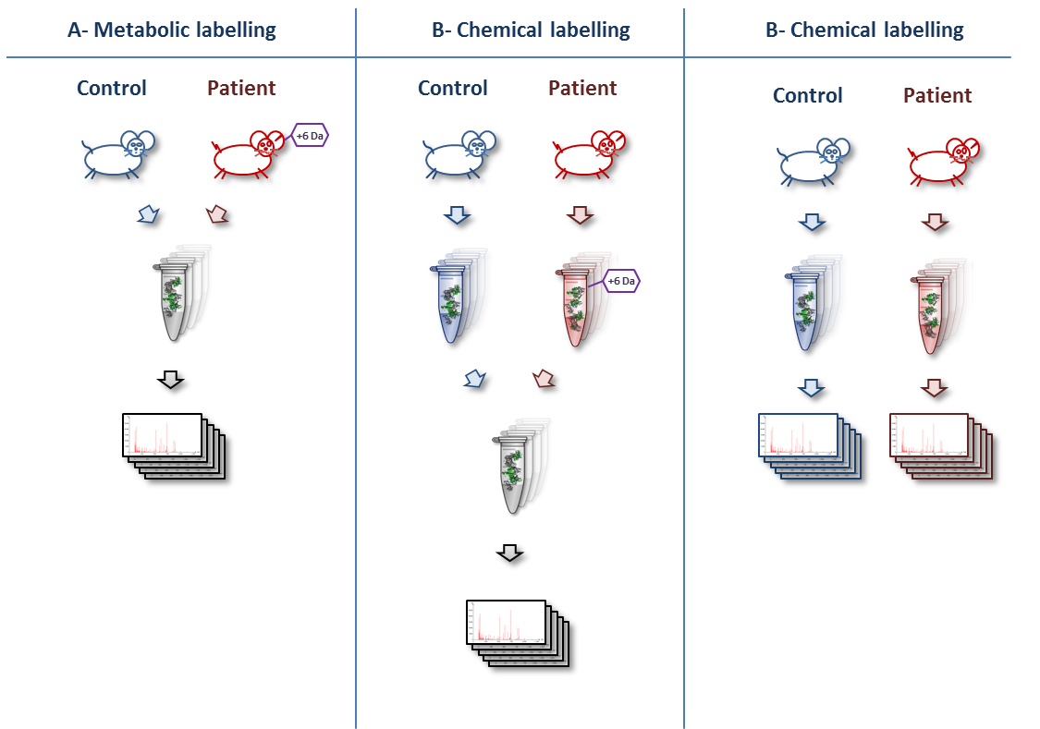

The protein amount can be inferred from different metrics:

**MS1 intensities**

Comparing peptide intensities in the survey scans is the gold standard approach for relative quantification. It is also used for absolute quantification by summing up peptide intensities of every protein.

**The MS/MS spectrum count**

It is the simplest way to estimate the abundance of a protein: it relies on the fact that abundant proteins are more likely to trigger the measurement of MS/MS spectra.

**MS2 intensities**

There are two major uses of the MS2 intensities for quantification. The first one is based on so-called reporter ions generated by the label applied to every sample. The relative comparison of the intensities of these ions is used to estimate the relative abundance of every identified peptide or protein.

The MS2 intensities are also used in a targeted way, called Selected Reaction Monitoring (SRM), where the mass spectrometer targets a so-called transition consisting of the combination of a peptide and a fragment ion. A fragment ion intensity standard provides an estimate of the protein abundance.

**Sample Comparison**

In all cases, comparing the quantitative signals from the different samples provides an estimate of the relative abundance of the measured species – with more or less accuracy. The absolute quantification is achieved by comparing the quantitative signal to an internal standard. It is important to note here the potentially important bias introduced by protein digestion and peptide ionization. When possible, a spiked-in labelled version of the quantified species is usually used as internal standard.

**Overview**

This chapter presents the bioinformatics and methods the statistical techniques involved in quantitative studies, covering the following approaches:

**2.1 Spectrum counting**

**2.2 Reporter ions**

**2.3 Label-free MS1**

**2.4 Labeled MS1**

**2.5 SRM**

**2.6 Statistical Analysis**

References

1. Bantscheff, M., Lemeer, S., Savitski, M.M. & Kuster, B. Quantitative mass spectrometry in proteomics: critical review update from 2007 to the present. *Analytical and bioanalytical chemistry* **404**, 939-965 (2012).

2. Bantscheff, M., Schirle, M., Sweetman, G., Rick, J. & Kuster, B. Quantitative mass spectrometry in proteomics: a critical review. *Analytical and bioanalytical chemistry* **389**, 1017-1031 (2007).

3. Vaudel, M., Sickmann, A. & Martens, L. Peptide and protein quantification: A map of the minefield. *Proteomics* **10**, 650-670 (2010).

4. Domon, B. & Aebersold, R. Options and considerations when selecting a quantitative proteomics strategy. *Nat Biotech* **28**, 710-721 (2010).